EXPERIMENT:12: Demonstrate Infrastructure as a Service (IaaS) by creating a resources group using a Public Cloud Service Provider (Azure), configure with minimum CPU, RAM, and Storage.

STEP:1:: FIRSTLY, OPEN THE AZURE AND THEN GO THE CREATE AND THEN FILL THE BASICS .

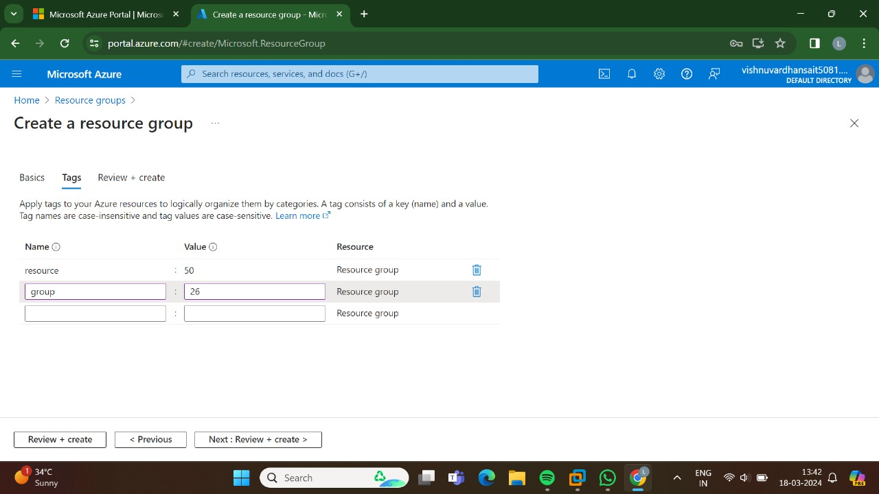

STEP:2: AND THEN NEXT GO TO THE TAGS.

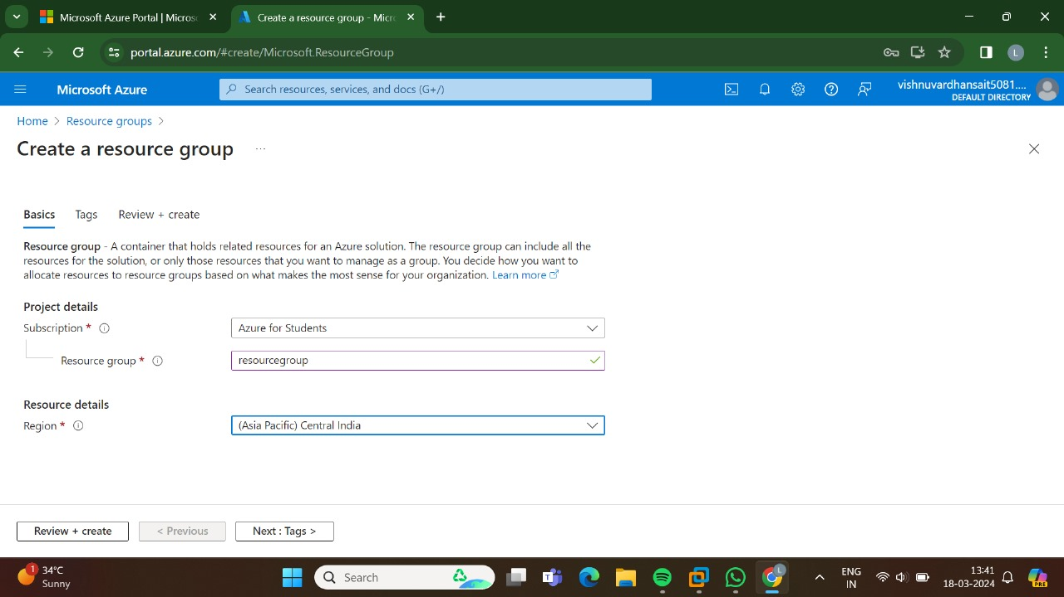

STEP:3:: AND THEN ATLAST GO TO THE REVIEW +CREATE AFTER CLICKING THIS THE VA;IDATION WILL BE SUCEEDED.

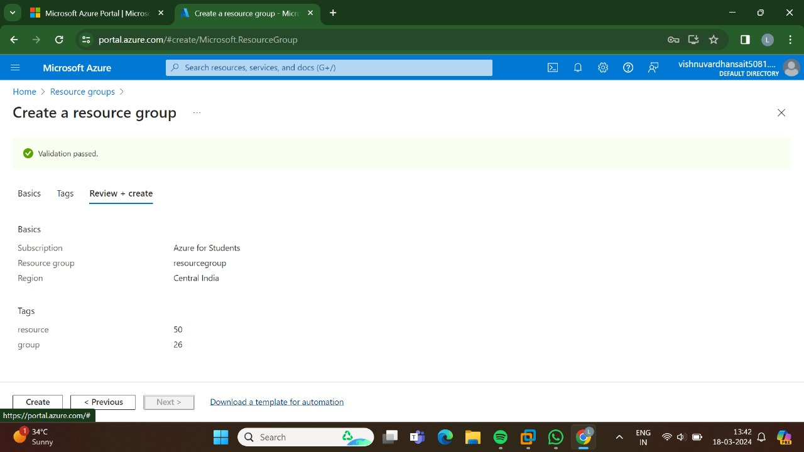

STEP:4: HENCE,HERE IS THE OUTPUT FOR THE RESOURCE LAYER IN AZURE.

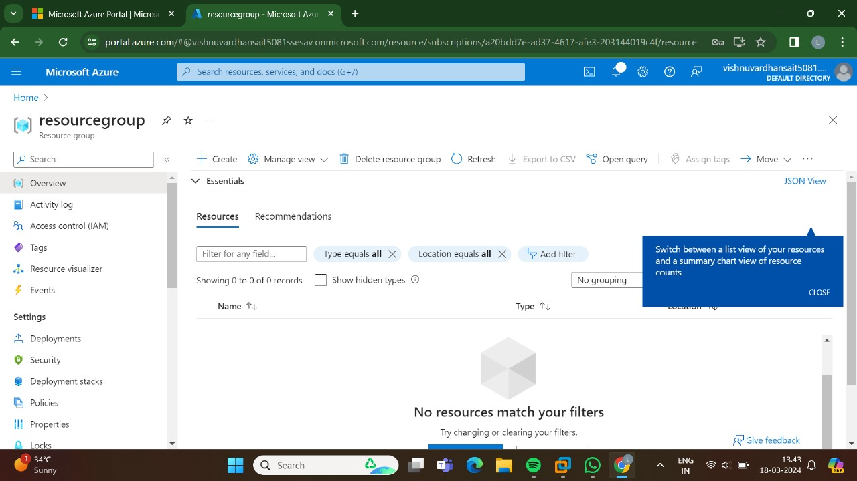

RESULT: THUS,THE PROGRAM FOR THE RESOURCE GROUP IN AZURE HAS BEEN DONE SUCCESSFULLY.